Units 8 Answers
Hypothesis Testing Using LibreOffice

The Related Samples t Test

The Two -Tailed Test
Example 8.4 for container design data in Data Set F in workbook Exa 8.4F.xlsx using Paired t-test.
See spreadsheet Exa 8.4F The Two Tailed Test Containers worked.ods.

Paired t-test
Alpha | 0.050
Hypothesized Mean Difference | 0.000
 | Variable 1 | Variable 2
Mean | 172.600 | 159.400
Variance | 750.267 | 789.378
Observations | 10.000 | 10.000
Pearson Correlation | 0.863
Observed Mean Difference | 13.200
Variance of the Differences | 210.844
df | 9.000
t Stat | 2.875
P (T<=t) one-tail | 0.009
t Critical one-tail | 1.833
P (T<=t) two-tail | 0.018
t Critical two-tail | 2.262
The associated two-tailed p-value is p = 0.018, so the observed t is significant at the 5% level (two-tailed).

Exercise 8.4 for filtration data of Data Set G in workbook Exe8.4G.xlsx using a two-tailed test to determine whether the population mean impurity differs between the two filtration agents, and interpret your findings.
See spreadsheet Exe 8.4G The Two Tailed Test Filtration Exercise worked.ods.

Paired t-test
Alpha | 0.050
Hypothesized Mean Difference | 0.000
 | Variable 1 | Variable 2
Mean | 8.250 | 8.683
Variance | 1.059 | 1.078
Observations | 12.000 | 12.000
Pearson Correlation | 0.901
Observed Mean Difference | -0.433
Variance of the Differences | 0.212
df | 11.000
t Stat | -3.264
P (T<=t) one-tail | 0.004
t Critical one-tail | 1.796
P (T<=t) two-tail | 0.008
t Critical two-tail | 2.201
Difference in Means | -0.433

The associated two-tailed p-value is p = 0.008, so the observed t is significant at the 5% level (two-tailed) and the null hypothesis should be rejected.

The One-Tailed Test
Example 8.5
A one-tailed t test of whether the underlying (population) mean number of items sold differs between the two container designs of data Set F.
See spreadsheet Exa 8.5F The Two Tailed Test Containers worked.ods.

Paired t-test
Alpha | 0.050
Hypothesized Mean Difference | 0.000
 | Variable 1 | Variable 2
Mean | 172.600 | 159.400
Variance | 750.267 | 789.378
Observations | 10.000 | 10.000
Pearson Correlation | 0.863
Observed Mean Difference | 13.200
Variance of the Differences | 210.844
df | 9.000
t Stat | 2.875
P (T<=t) one-tail | 0.009
t Critical one-tail | 1.833
P (T<=t) two-tail | 0.018
t Critical two-tail | 2.262
Difference in Means | 13.200

The associated one-tailed p-value is p = 0.009, so the observed t is significant at the 1% level (one-tailed).

Exercise 8.5
A one-tailed test had been conducted to determine whether Filter Agent 1 was the more effective in Data Set G.. What would your conclusions have been?
See spreadsheet Exe 8.5G The One Tailed Test Filtration Exercise worked.

Paired t-test
Alpha | 0.050
Hypothesized Mean Difference | 0.000
 | Variable 1 | Variable 2
Mean | 8.250 | 8.683
Variance | 1.059 | 1.078
Observations | 12.000 | 12.000
Pearson Correlation | 0.901
Observed Mean Difference | -0.433
Variance of the Differences | 0.212
df | 11.000
t Stat | -3.264
P (T<=t) one-tail | 0.004
t Critical one-tail | 1.796
P (T<=t) two-tail | 0.008
t Critical two-tail | 2.201
Difference in Means | -0.433

The associated one-tailed p-value is p = 0.004, so the observed t is significant at the 1% level (one-tailed) and the null hypothesis should be rejected. A higher level of significance was obtained with the one-tailed test compared to the two-tailed test.

The sample mean numbers for impurities ppm for Agents 1 and 2 were 8.250 and 8.683 respectively. The data therefore constitute significant evidence that the underlying mean number of impurities ppm was greater for Agent 2 by an estimated 0.433. As there was less impurities in Agent 1 then Agent 1 should be preferred.

The INDEPENDENT Samples t Test

Example 8.6
F Test conducted on dietary data in Data Set B from workbook Exa 8.6B.xlsx.
See spreadsheet Exa 8.6B The INDEPENDENT Samples t Test diet worked.ods.

The repeated example output is:

F-test
Alpha | 0.050
 | Variable 1 | Variable 2
Mean | 5.341 | 3.710 | The sample mean weight losses for Diets A and B
Variance | 6.429 | 7.668 | sample variances for the two diets
Observations | 50.000 | 50.000
df | 49.000 | 49.000 | associated degrees of freedom
F | 0.839 |  | observed F test statistic
P (F<=f) right-tail | 0.730
F Critical right-tail | 1.607
P (F<=f) left-tail | 0.270
F Critical left-tail | 0.622
P two-tail | 0.540 | p2 | 3.215
F Critical two-tail | 0.567 | 1.762
two tailed | 0.00275154 | p value | The associated two-tailed p-value is p = 0.0028, so the observed t is significant at the 1% level (two-tailed).[=TTEST(B2:B51,B52:B101,2,2)]
one tailed | 0.00137577 | p value

A two-tailed t test was conducted to test whether the population mean weight losses differ between the two diets using the formula =TTEST(data1;data2;mode;type) with =TTEST(B2:B51,B52:B101,2,2)

Exercise 8.6
Complete an appropriate test bank cardholder data of Data Set C in workbook Exe8.6C.xlsx to determine whether the population mean income for males exceeds that of females and interpret your findings. What assumptions underpin the validity of your analysis, and how could you validate them?
See spreadsheet Exe 8.6C Bank Cardholders appropriate tests exercise working.ods

Comparison tests look for differences among group means. They can test the effect of a categorical variable (in this case gender) on the mean value of another characteristic such as income. T tests are used when comparing the means of exactly two groups. The T-test is used to compare the means of two groups; Paired t-test groups come from same population whereas Independent t test groups come from different populations. An appropriate test of whether the population mean income for males exceeds that of females is the Independent T-Test.

Statistical assumptions are: independence of observation, uniformity of variance (similar within each group) and data is normally distributed.

The Null hypothesis: the sample income mean of male group is not different from the sample mean of female group. The Alternative; the sample income mean from male group is significantly different from female group.

The formula used to calculate the independent T-test in LibreOffice was [=TTEST(B2:B61,B62:B121,2,2)].

The exercise output is:
Independent T Test
two tailed p value | 0.00142

The associated two-tailed p-value is p = 0.00142, so the observed t is significant at the 1% level (two-tailed).

The data therefore constitute strong evidence that the underlying mean income was greater for male bankcard holders than female bankcard holders. The difference in means between both groups is 8.68 (,000s).

Unit 9 Answers

Bar Charts Using LibreOffice
Example 9.1
Percentage frequency bar chart for breakfast cereal brand preferences using Data Set D in workbook Exa 9.1D.xlsx.
See spreadsheet Exa 9.1D example working.ods.

Completed chart example for Area 1.

Exercise 9.1
Add a percentage frequency bar chart showing the brand preferences in Area 2.
Percentage frequency bar chart for breakfast cereal brand preferences in Area 2 using Data Set D in workbook Exe 9.1D.xlsx.
See spreadsheet Exe 9.1D exercise working.ods

Brand A has least sales in both Area 1 and 2. Brand Other has most sales in both Areas.
The preference for Brand Other is more pronounced in Area1 compared to Area 2.

Example 9.2
Percentage frequency clustered column bar chart for the breakfast cereal brand preferences for the two demographic Areas 1 and 2 using Data Set D in workbook in Exa 9.2D.xlsx.
See spreadsheet Exa 9.2D exercise working.ods

Exercise 9.2
Percentage frequency clustered column bar chart showing the heather species prevalences in the two different locations using Data Set E in workbook Exe 9.2E.xlsx.
See spreadsheet Exe 9.2E exercise working.ods.

Location B has a significant absence of heather species compared to Location A. However when the prevalence is sparse, there is more of an equivalence in frequencies for both locations. When the prevalence is abundant, Location A dominates in terms of frequency.

Example 9.3
A relative frequency histogram for the weight losses of those individuals who underwent Diet A using Data Set B in workbook Exa 9.3B.
See spreadsheet Exa 9.3B histograms example working.ods.

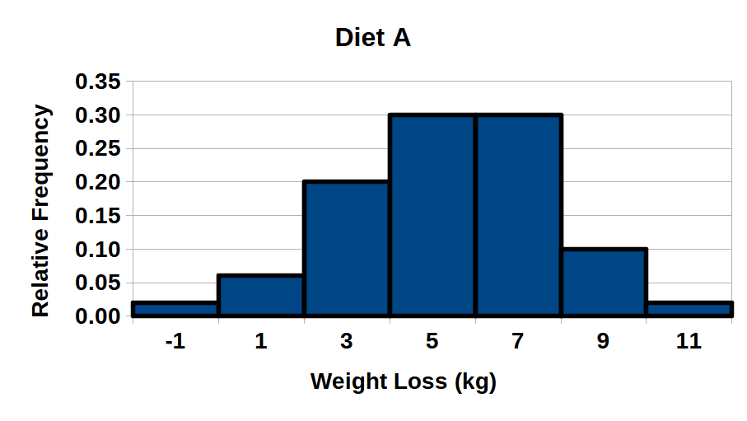
Exercise 9.3
A relative frequency histogram for the weight losses of those individuals who underwent Diet A and B using Data Set B in workbook Exe 9.3B.
See spreadsheet Exa 9.3B histograms example working.ods.

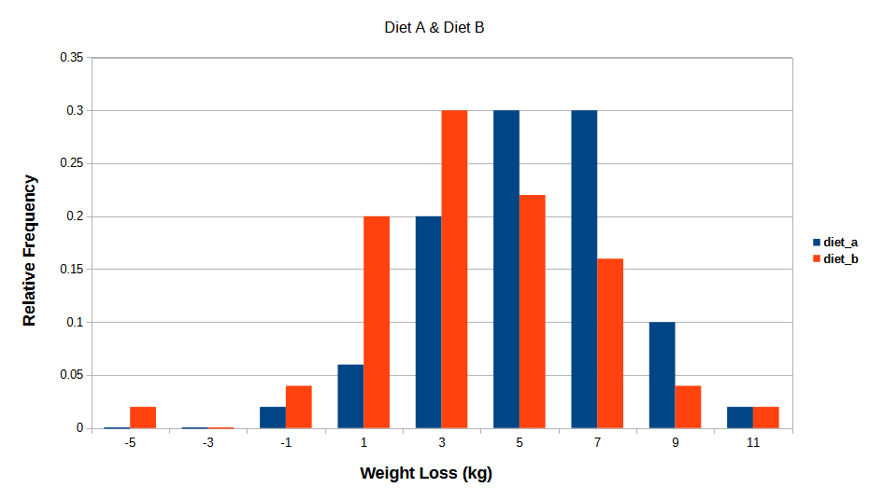

The patterns of weight loss for each of the two diets are normally distributed. Diet B has a lower loss median than Diet A.

